Guide 2. APT Project Development
Capstone Course

1. Project APT Progress Summary
Summary of Project APT Progress
During this phase, the formal development process of the NutPsi project, corresponding to the APT Project, has begun. The initial configuration of the work environment, methodological definitions, and team organization were completed.
The use of Jira was replaced by Trello as the main agile management tool, as it facilitates task visualization and real-time team collaboration. The Trello board was structured into lists corresponding to Sprints 0–4, each with detailed tasks, descriptions, checklists, and acceptance criteria.
Additionally, the Scrum methodology was defined, and a GitHub repository was implemented for code version control. Activities such as planning, MVP definition, requirements gathering, and UI/UX prototype design in Figma were completed, enabling progress toward the iterative development of the application.
However, we experienced a significant delay in implementing the chatbot using Rasa due to the technical complexity and learning curve associated with this tool. This required adjustments to the initial schedule and the allocation of additional time for research and controlled testing.

Objectives
- Develop a comprehensive educational mobile application that combines the recording of physical and emotional indicators with personalized nutrition and physical activity plans for young adults.
- Implement a geolocation system in the chatbot to connect users with psychologists and nutritionists available in their area, facilitating access to specialized professional care.
- Manage the agile development of the project using Trello and the Scrum methodology, documenting progress through concrete evidence from each sprint that validates progress toward a functional MVP.

Methodology
The agile Scrum methodology is maintained, with planned iterations across five sprints:
- Sprint 0: Project initiation and work environment setup.
- Sprint 1: Discovery and prototype design.
- Sprint 2: Iterative development of the main functionalities.
- Sprint 3: System testing and validation.
- Sprint 4: Final delivery and project closure.
Tasks and the backlog are managed using Trello, complemented by GitHub for version control and Figma for UI/UX design.

Progress Evidence
- Structured Trello board.
- GitHub repository with the project structure.
Evidence: Currently working on the feature/menu branch.
- UI/UX prototype in Figma validated by users.
Prototype link for full experience: Mockup NutPsi
Within the following interfaces, you can visualize the use of the application’s features in development, such as login, registration, and indicator plans.
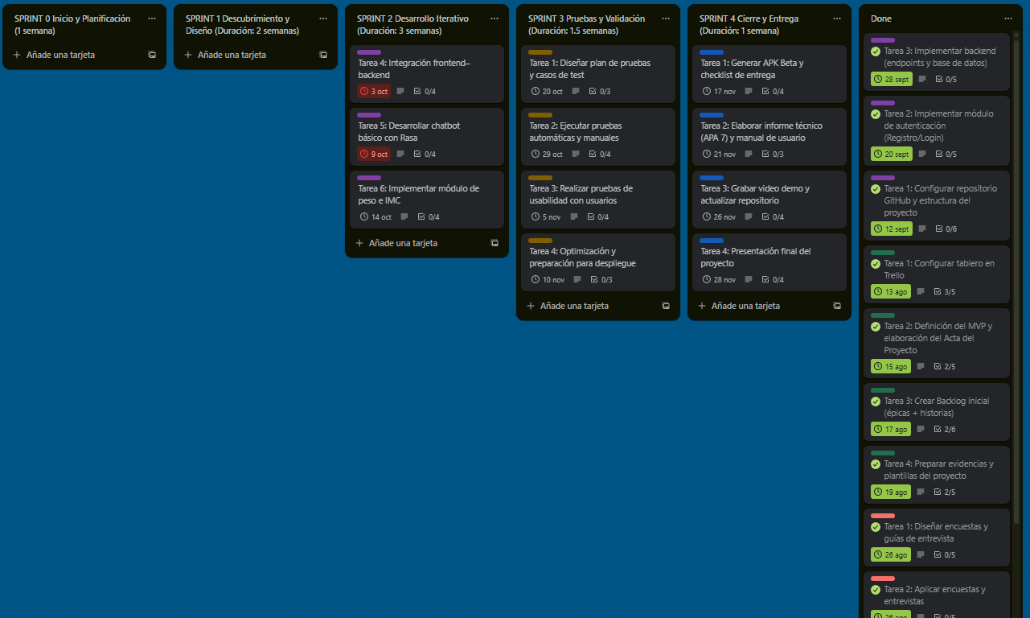

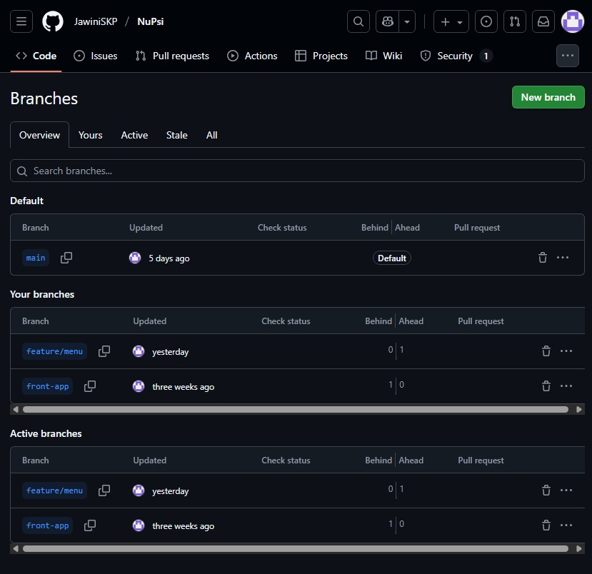
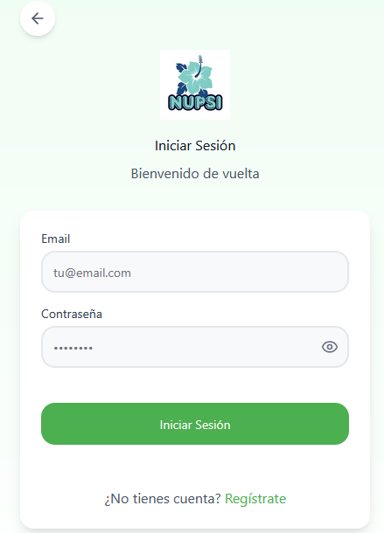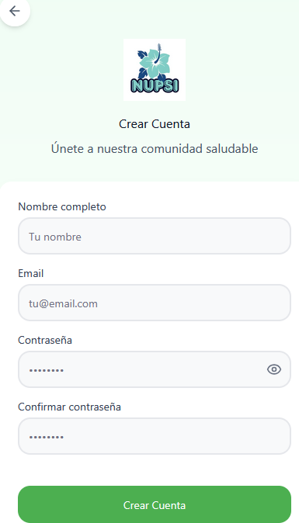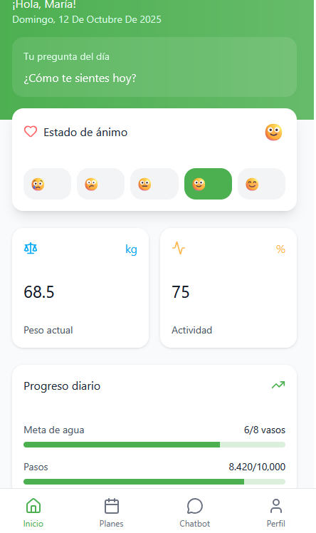

Quality Assurance
Quality is ensured through:
- Application of Scrum best practices (sprints, retrospectives, prioritized backlog).
- Use of GitHub for version control.
- Continuous requirement validation with evidence documented in Trello.
- Functionality testing in a local environment before deployment.

Application Features
- Login, registration, and Google account login.
- Indicator registration.
- Rasa chatbot suggesting nearby psychologists and nutritionists.
- Systematic architecture for future implementations.
- Firebase as the database.

Application Evidence
Below is the login section. If the user already has a registered account, they can access the home screen of the application using their username and password or sign in with their Google account.
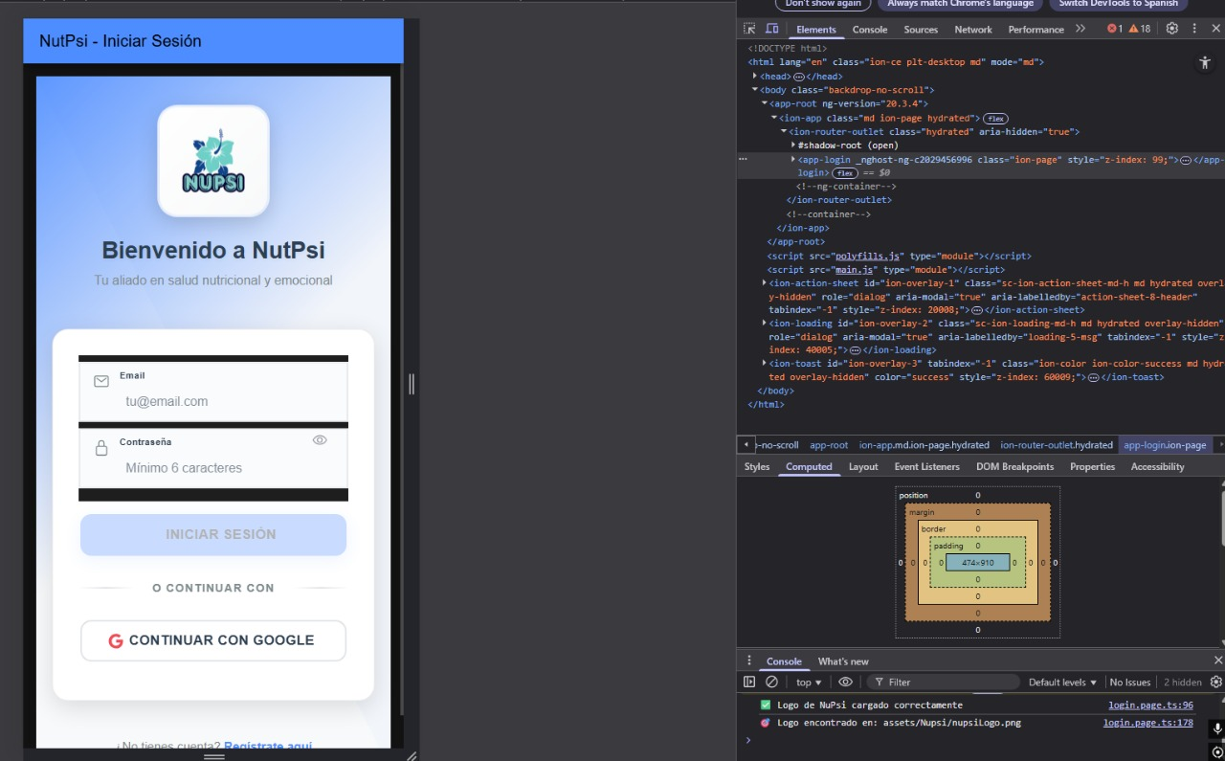
If the user does not have an account, they can go to the “Create Account” section and choose to register with Google or by filling out the validated form.
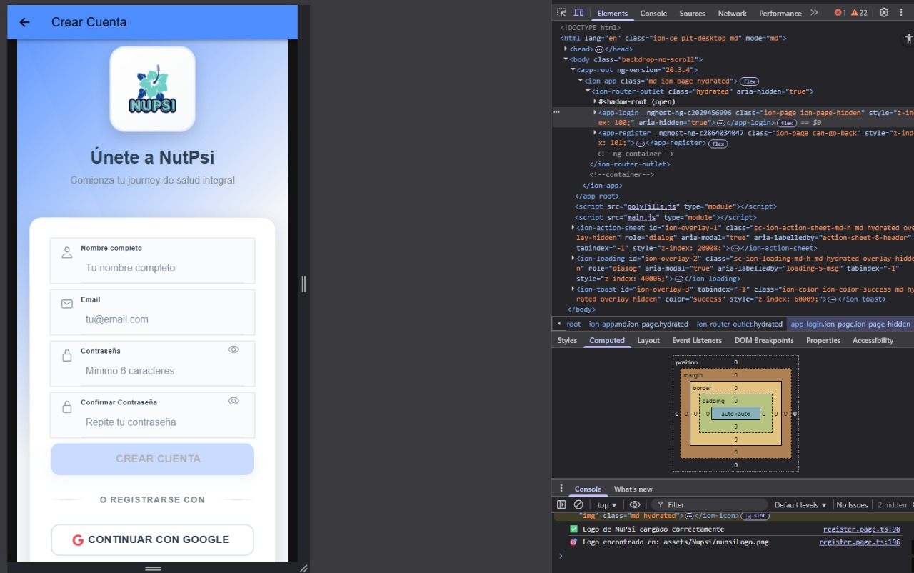
Here we can see a test of logging in with a registered account and then signing in with Google.
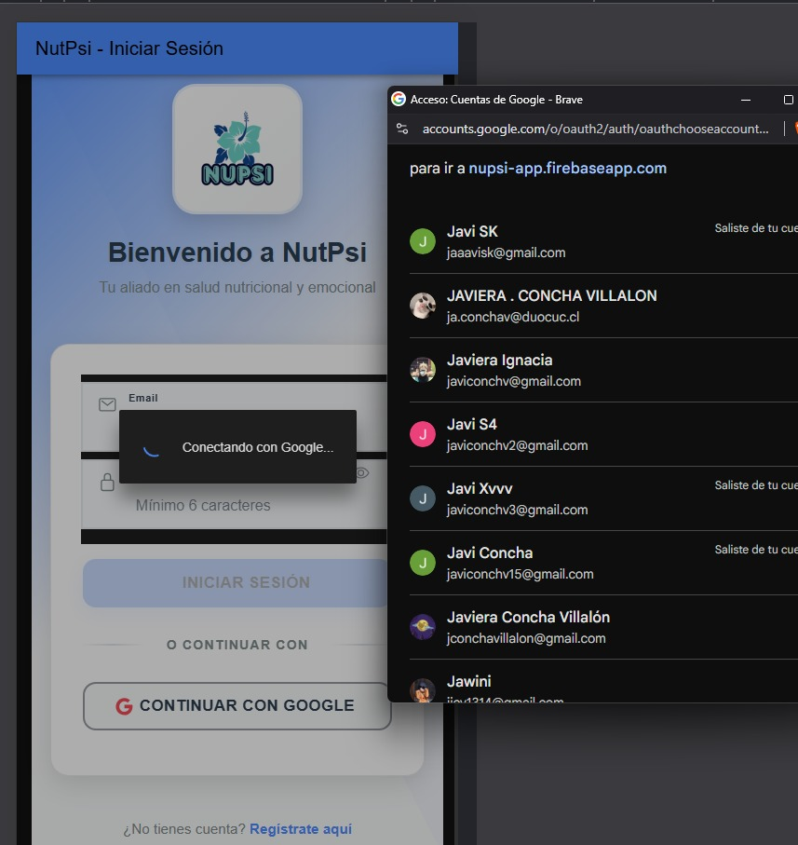
Once the account is successfully validated upon login, the system displays the date and username of the account. In the Google terminal, the successful login process can be seen in detail. Some aspects still need improvement.
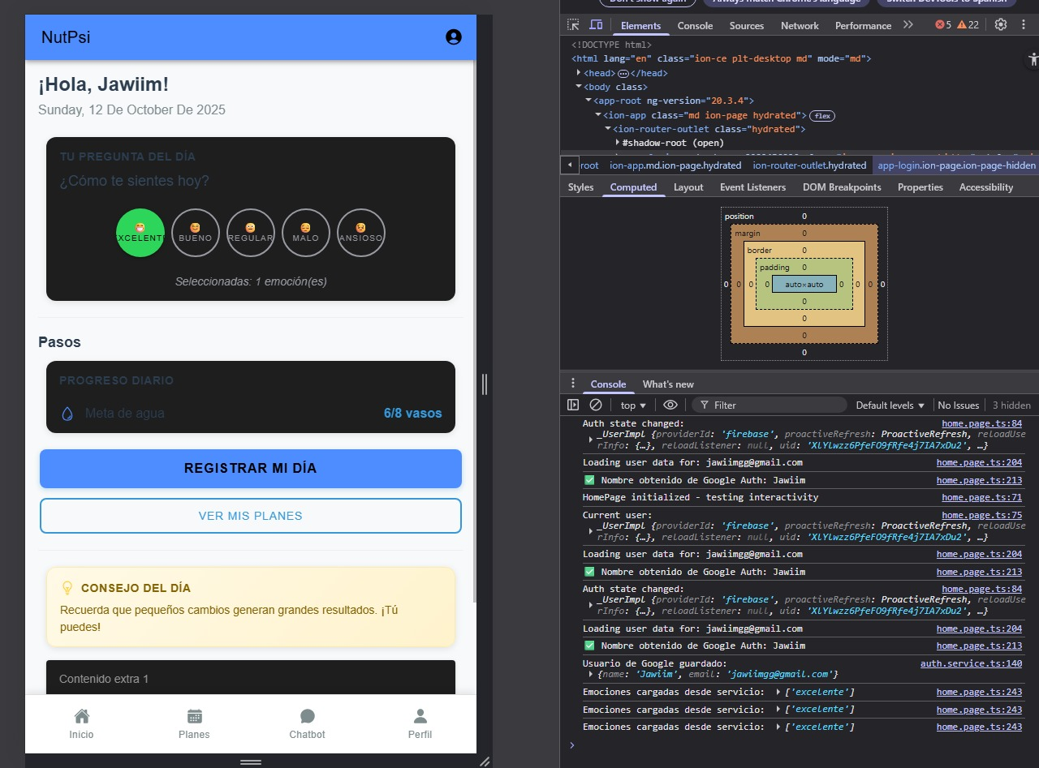
Below, the Indicator Form version 1.0 is shown, along with a record saved in the Firebase database. In the Google terminal, you can verify that it was stored correctly.
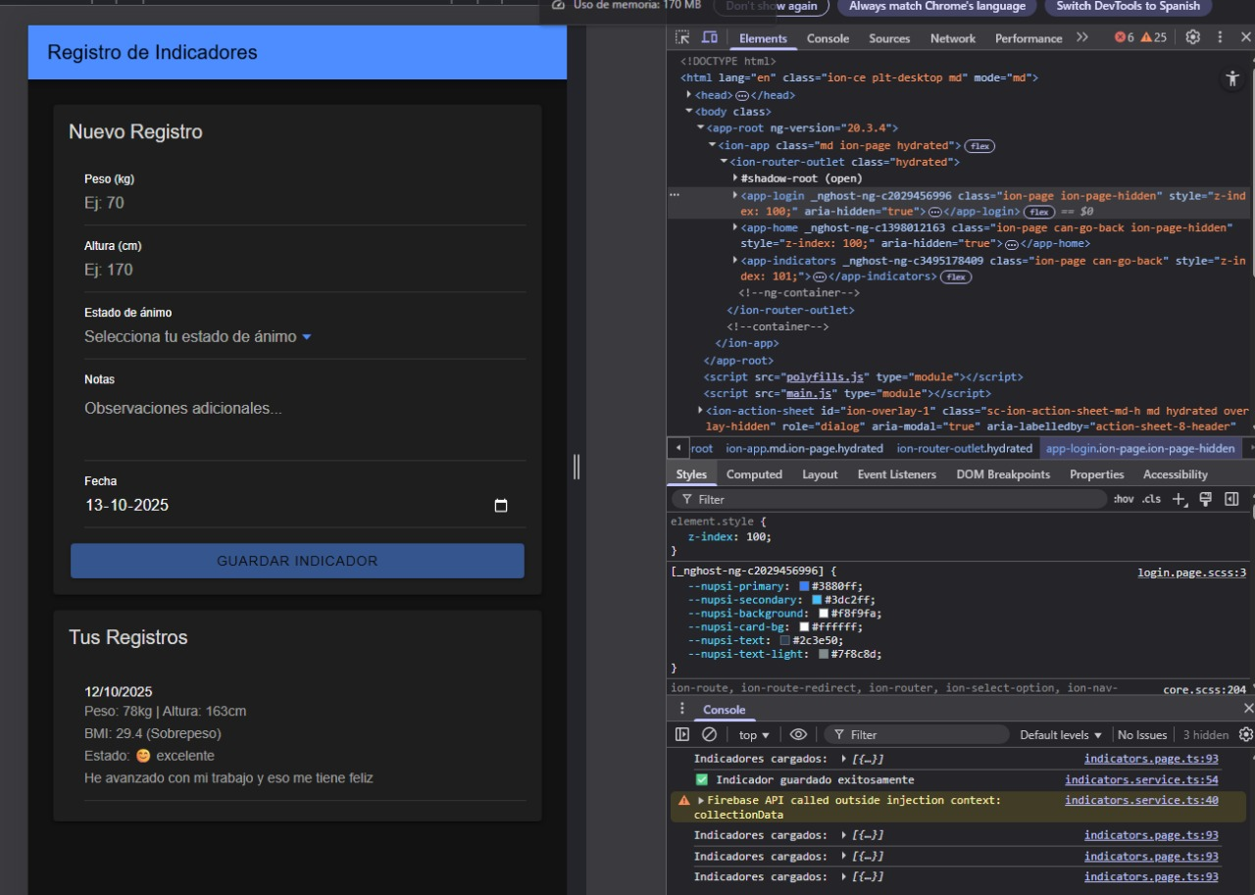
Here, the database displays the “indicators” section that was filled in earlier. The user ID and entered data appear, demonstrating that the application functions correctly and stores data properly.
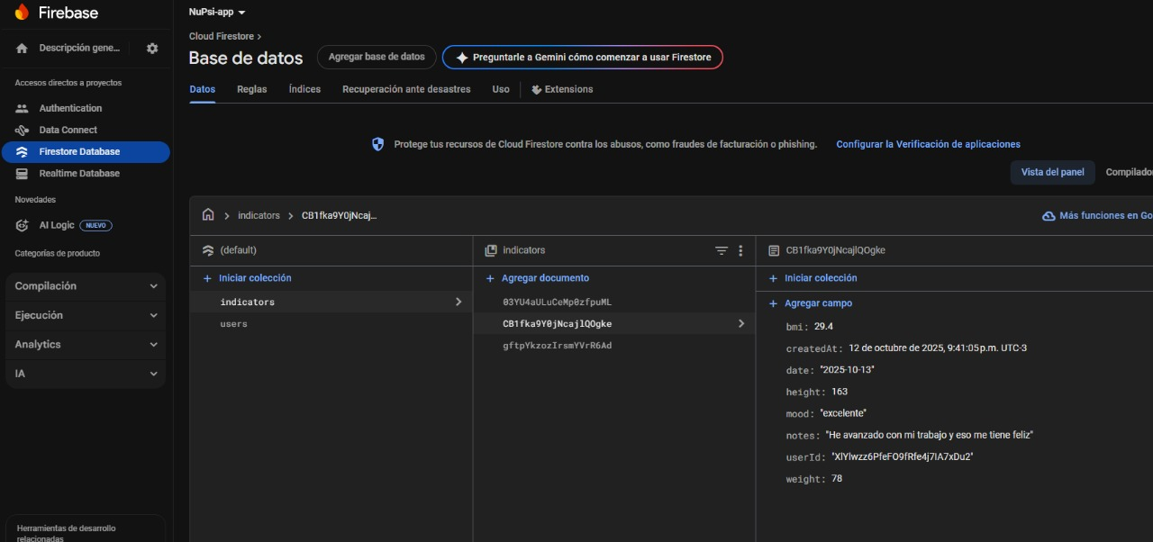
The following section shows all commits created so far. We focus on the latest commit made by the team, as it represents a major milestone. However, we acknowledge there are still areas for improvement. We will now divide tasks to focus on developing the chatbot with Rasa.
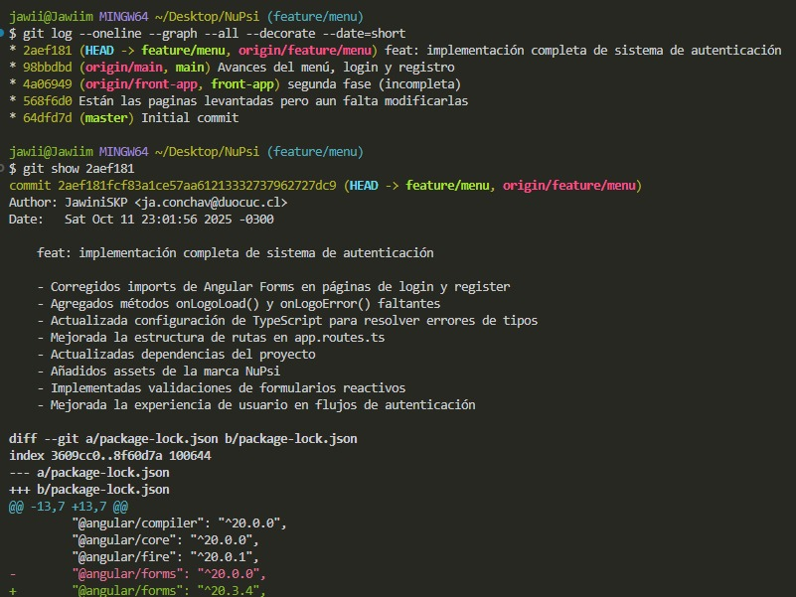

Team Organization and Meetings
Below is the record of our organization and meetings.
We connect via Discord for teamwork, store our project backups on WhatsApp and Google Drive.
Attached images:
- Work meeting on Discord
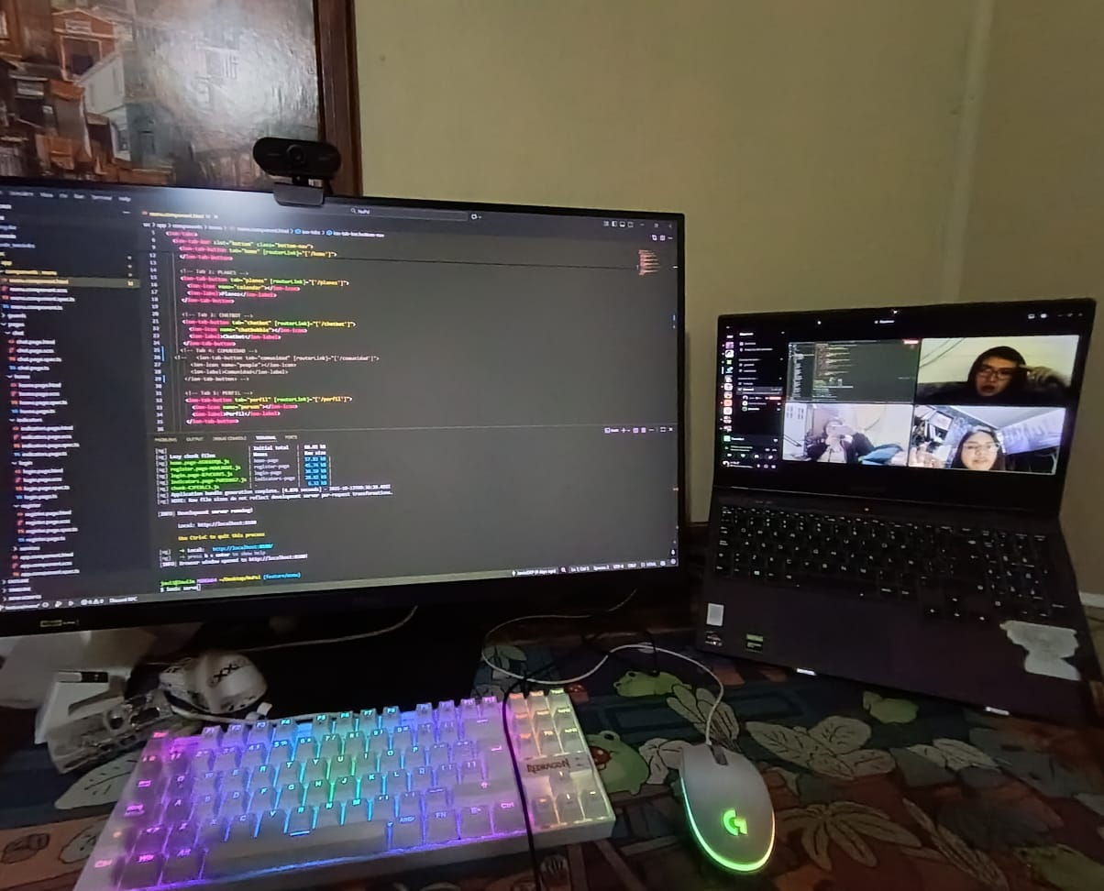
- Capstone WhatsApp group
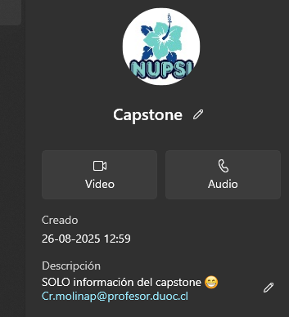
- Google Drive
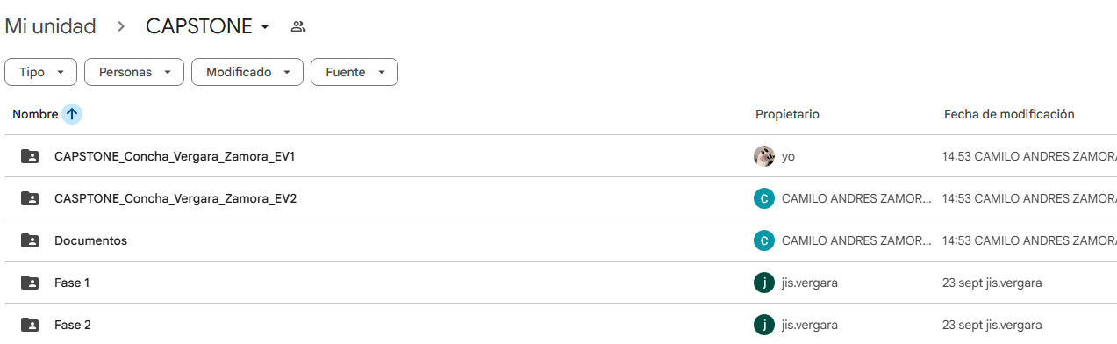

Competence / Unit | Main Activities | Resources | Duration | Responsible | Observations | Status | Adjustments
Project Planning | Configuration of Trello and GitHub | Trello, GitHub | 1 week | Jisella Vergara | Workflow established | Completed | Jira replaced by Trello
Requirements Analysis | Design and implementation of surveys | Google Forms | 2 weeks | Team | Good user feedback | Completed | No adjustments
UI/UX Design | Creation of prototype in Figma | Figma | 1 week | Design Team | Prototype validated with users | Completed | No adjustments
Iterative Development | Implementation of MVP (authentication, BMI, chatbot) | GitHub, VS Code | 3 weeks | Development Team | Requires testing | In progress | Adjusted RASA backlog (task optimization)
System Validation | Unit and usability testing | Postman, Jest | 1.5 weeks | QA | Pending execution | Not started | Planned for next sprint
Project Closure | Final report and demo video | Word, Canva | 1 week | Entire Team | In planning | Not started | To be executed in Sprint 4

Factors That Facilitated Development
- The use of Trello has improved task organization and visibility, allowing for easy distribution of responsibilities and progress tracking.
- Effective team communication through digital channels (Drive, WhatsApp, and virtual meetings) has optimized coordination.
- Early validation of requirements and prototypes helped reduce errors prior to the development phase.

Factors That Hindered Development and Actions Taken
- Initial delays due to the learning curve in using tools such as Trello, GitHub, and RASA.
Action: Tutorials and internal training sessions were assigned.
- Limited time availability among team members.
Action: Tasks were reorganized and redistributed according to each member’s weekly workload.

Adjusted or Removed Activities
- The use of Jira was discontinued and replaced with Trello as the main planning tool, due to its greater ease of use and collaboration. This modification was made because of Jira’s associated financial constraints.
Evidence:
The timelines for Sprint 2 were adjusted to include more integration time between modules (backend–frontend). These adjustments were documented and marked as Done in the status board.
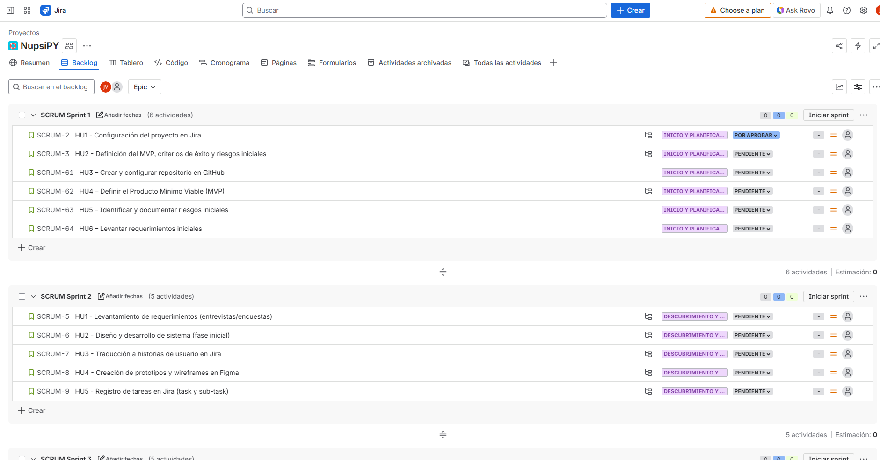
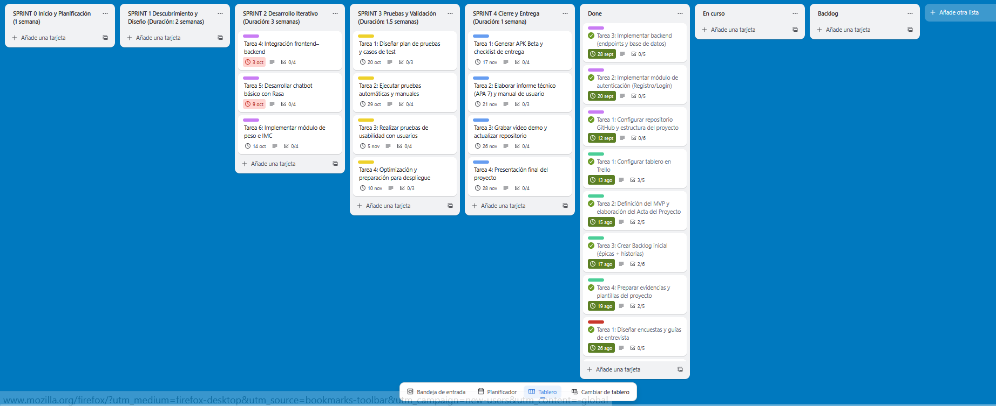
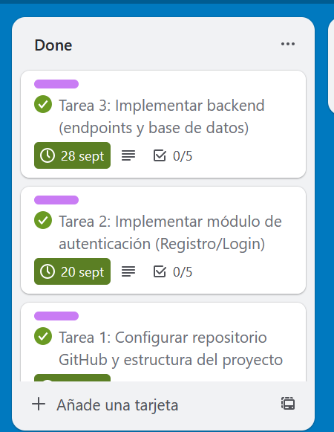

Unstarted or Delayed Activities
- Activities corresponding to Sprint 3 (testing and validation) have not yet started, as they depend on the completion of the MVP.
Strategy:
A more detailed testing plan will be applied, including automated test cases and user testing at the end of Sprint 2.
Trello Board:
https://trello.com/invite/b/67d897f2630254e44d290673/ATTI1cb746c1aa7c6221c4b9a5244ec6bfd5F8DDBCA8/nupsy

